Week 4 ELA: April 27th

TIME | MONDAY | TUESDAY | WEDNESDAY | THURSDAY | FRIDAY
20 minutes  IREADY | IReady-  Click on the link below to get your minutes!  IREADY | IReady-  Click on the link below to get your minutes!  IREADY | IReady-  Click on the link below to get your minutes!  IREADY | IReady-  Click on the link below to get your minutes!  IREADY | IReady-  Click on the link below to get your minutes!  IREADY
20 minutes  Independent reading - choose from one of the two reading websites and explore books independently. | Get Epic!  Storyline  Scholastic Learn at Home  Scholastic Literacy Pro | Get Epic!  Storyline  Scholastic Learn at Home  Scholastic Literacy Pro | Get Epic!  Storyline  Scholastic Learn at Home  Scholastic Literacy Pro | Get Epic!  Storyline  Scholastic Learn at Home  Scholastic Literacy Pro | Get Epic!  Storyline  Scholastic Learn at Home  Scholastic Literacy Pro
20 minutes  Reading Lesson | Asking and Answering Questions Video 1  Complete Asking and Answering Questions Worksheet 1 | Asking and Answering Questions Video 2  Complete Asking and Answering Questions Worksheet 2 | Today’s story-  CLICK to see today's book!!  Before reading-  Write down a question  Pause in the middle-  Write down a question you have  At the end-  What is something you are still wondering? | Today’s story-  CLICK to see today's books!!  Before reading- write down a question.  After reading-  Were any of your questions answered?  Play WORD MATCH. It is on the left hand side. Use context clues to help you! | Choose your own story that you would like to read. (Kidsa-z, scholastic literacy pro, storyline)  Before reading- write down a question.  Pause in the middle-  Write down a question you have  At the end-  A question you still have or something you are still wondering about.
Writing  30 minutes | Practice your typing!  Typing game | FREE WRITE-  You may write about whatever you would like. It could be a fiction, made up story. It could be writing about someone in your family or a pet. It could be writing about the changes with everything going on right now.  It is your choice! | 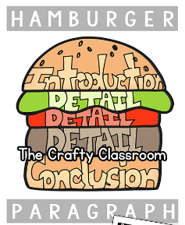  Let’s review writing a paragraph this week.  I put a visual of a hamburger to help you remember about paragraphs. There should be five sentences. There should be an introduction or opening sentence. There should be a closing or conclusion sentence. | 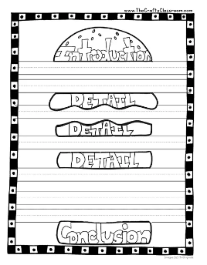Choose someone you are at home with. Write a paragraph about them.  Use the hamburger template to help you. | 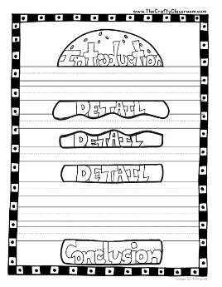  Choose your favorite activity. Anything fun you like to do!! Write a paragraph about it.  Use the hamburger template to help you.

